EXP NO 2: CREATE A SIMPLE CLOUD SOFTWARE APPLICATION FOR FLIGHT RESERVATION
SYSTEM USING ANY CLOUD SERVICE PROVIDER TO DEMONSTRATE SAAS.
DATE:30-07-26 Name:P.Sri Kousick
Regno:192524431
AIM:To create a simple cloud software application for flight reservation system using any cloud service provider to demonstrate saas.
PROCEDURE:
step1: Go to zoho.com. step 2: Log into the zoho.com. step 3: Select one application step. step4: Enter
application name as flight reservation system. step 5: Created new application flight reservation system. step 6: Select one form step 7: The
software has been created.
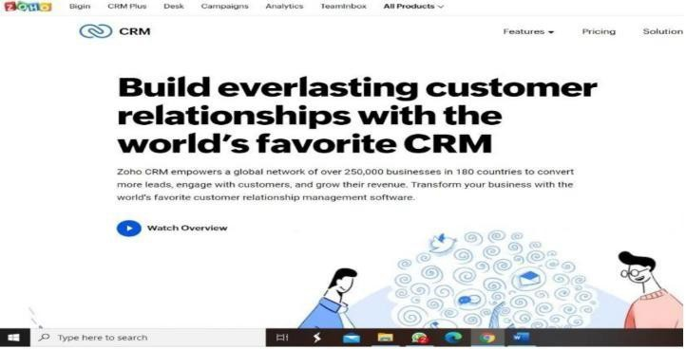
IMPLEMENTATION: STEP1: GOTO ZOHO.COM

STEP 2: LOGINTOTHE ZOHO.COM
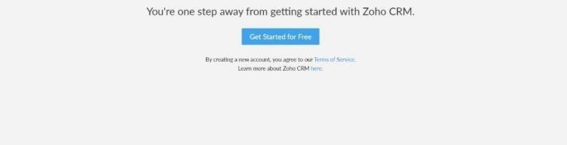

STEP 3: SELECT ONE APPLICATION
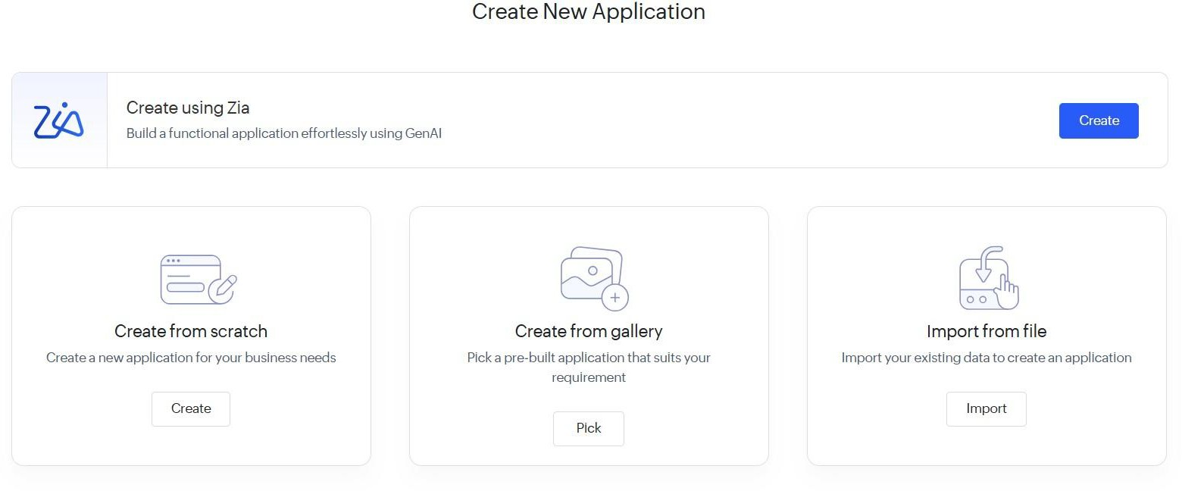

STEP 4: ENTER APPLICATION NAME
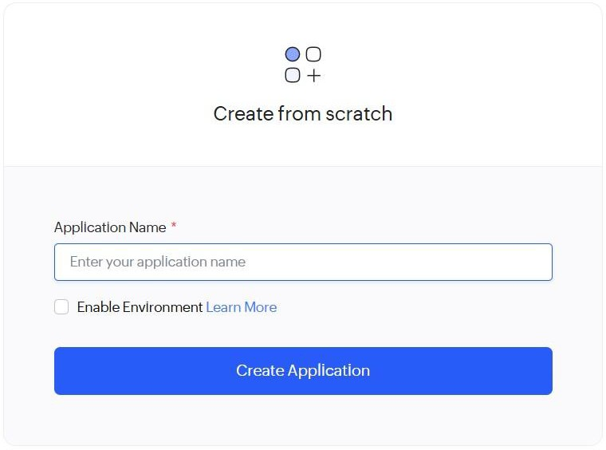

STEP 5: CREATED NEW APPLICATION
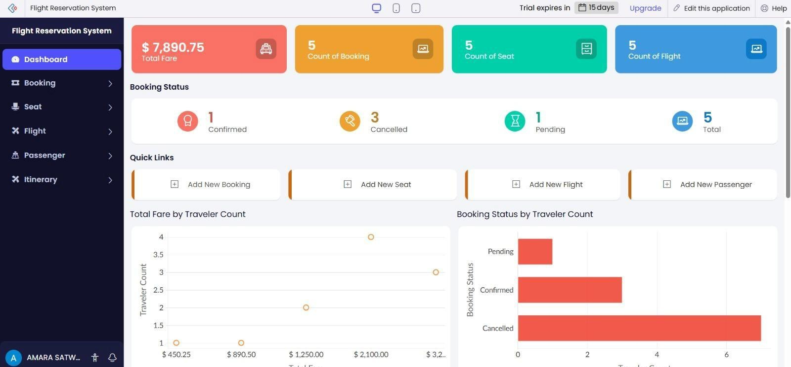
STEP 6: SELECT ONE FORM
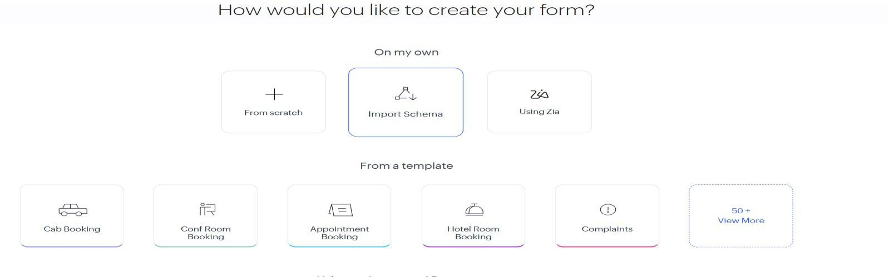
STEP 7: THE SOFTWARE HASE BEEN CREATED.
